Addy Carroll
Predictive Modeling – Final Report
May 14, 2025
Using a Data-Derived Susceptibility Index to Account for Model Bias under Drought
Introduction
Wheat production in Kansas is governed by a strong precipitation gradient increasing from east to west, with extremely restricted rainfall near the Colorado border, to adequate water availability in eastern Kansas (Kansas Mesonet, 2025). While growers predominantly rely on dryland systems, production in water-limited western Kansas often relies on supplemental applied irrigation to fully realize genetic yield potential (Ji et al., 2021). Consequently, Kansas wheat breeding programs must strike a balance between selecting for drought resilience under rainfed conditions and maintaining high yield capacity when water is non-limiting.
Assessing genotype performance across this spectrum of water availability poses significant challenges. Plant responses to soil moisture deficit involve complex physiological and developmental adjustments, and drought effects frequently co-occur with other abiotic stresses (e.g., heat, nutrient limitation) as well as disease pressures, confounding straightforward interpretation of yield data (Blum, 2015; Dolferus et al., 2019; Onyemaobi et al., 2021; Estrada et al., 2023).
The primary objective of this project was to evaluate six distinct Kansas environments, each subject to varying degrees of drought stress, and to develop a statistical framework that removes bias introduced by water deficit. A modified difference-based drought susceptibility index (DSI) is implemented to quantify each genotype’s relative sensitivity to drought, with the goal of generating predictions that more accurately reflect genotypic potential under well-watered conditions, rather than performance exclusively under stress (Fischer & Maurer, 1978). The hypothesis is that DSI-based bias correction would improve prediction accuracy in a non-stressed environment by disentangling drought-specific effects from inherent yield potential.
Methods
Overview of Research Population
This project utilized a population of 237 BC₂F_{4:5} wild introgression lines (WILs), generated by crossing an elite wheat recurrent background parent (Triticum aestivum) with wild emmer (Triticum turgidum subsp. dicoccoides) via an amphiploid bridge species to facilitate transfer of novel alleles and allele combinations. Leaf-tissue extracted DNA from each WIL was assayed on a 40k SNP array, and raw marker data were quality controlled, removing markers with >10% missing data (call rate < 0.90), markers with heterozygosity > 10%, and markers with minor allele frequency (MAF) < 0.05.
After filtering, 4,145 high quality markers remained, which were used to construct a genomic relationship matrix (GRM) according to the method of Zhang et al. (2010), which accommodates missing data through pairwise marker sharing and yields a positive semi-definite kernel suited for mixed model analyses. The resulting GRM underpinned all subsequent models of genetic similarity and genomic prediction.
Multi-Environment Trialing
The WILs were evaluated in six environments – three locations over three growing seasons (Table 1) – to capture a representative gradient of drought stress across Kansas. Field trials were laid out as a 50% partially replicated (p-rep) design, with the recurrent parent and standard performance checks included in ten complete replicates per site (Figure 1).
Phenotypic data consisted of grain yield (GY) at harvest in addition to other key yield component traits: plant height (PH) at physiological maturity; normalized difference vegetation index (NDVI), derived from near-infrared and red reflectance to assess canopy vigor; green reflectance (GR) as a proxy for chlorophyll content; senescence date (SD), scored when approximately 80% of tillers had lost green peduncle tissue; thousand kernel weight (TKW), measured via a Marvin kernel analyzer; and test weight (TW), determined gravimetrically using a Perten IM9500 instrument.
Table 1. Phenotypic testing environments for wild introgression lines (WILs) by county and growing season. Environments with successful data collection are indicated by an “X.”
Growing Season | Environment
 | Ellis County | Riley County | Thomas County
2020-2021 |  |  | X
2021-2022 | X | X | X
2022-2023 |  | X | X

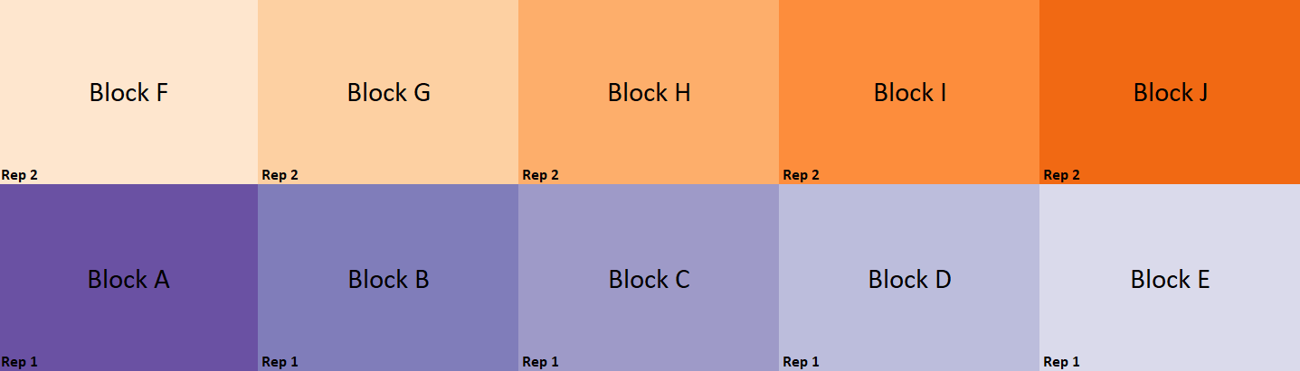
Figure 1. Schematic of the experimental design for trialing of wild introgression lines (WILs) conducted from 2020 to 2023. Each of the ten blocks (A-J) contained complete replications of all performance checks and the recurrent parent, while WILs with two replications were evenly distributed across two replicates (Reps 1 and 2).
Before spatial correction, raw observations for each trait within each environment were centered on the environment mean and scaled by the environment standard deviation, yielding standardized data (mean=0, SD=1) that served as input the first stage of the modeling process. To account for within-field spatial variation, separable AR1 x AR1 residual structures were fit in ASReml-R, enabling extraction of best linear unbiased estimates (BLUEs) and precision weights for each genotype within each environment (Gilmour et al., 1997; Butler et al., 2023).
Environmental Drought Characterization
Although all trials were intended to be under dryland management, the Thomas County site in the 2022-23 season (2023 THD) received an unplanned center-pivot irrigation in April 2023, followed by an extended period of above-average rainfall. This irrigation event decoupled in-field moisture conditions from Kansas Mesonet weather records, rendering environmental covariates unreliable for drought modeling at that site. Because 2023 THD also produced the highest mean grain yield of the six trials, it was designated as the well-watered control (WWC) environment.
Using yields from the WWC, the framework of Fischer and Maurer (1978) was adapted for standardized data to calculate a difference based drought susceptibility index (DSI), to quantify each genotype’s relative yield reduction under varying conditions of drought stress. Among the five remaining environments, the 2022 Riley County trial (2022 RL) – which received the most natural precipitation – was excluded from model training and reserved as an out-of-sample test environment. This leave-out approach allows for assessment of how modeling using DSI compares to modeling without adjusting for drought in terms of predictive performance under independent, drought-affected conditions.

Drought Susceptibility Index (DSI)
The drought susceptibility index for each WIL, or genotype g in drought environment d (DSI_{g,d}) was calculated as the ratio of that genotype’s yield reduction under stress to the mean yield reduction of the trial:
${DSI}_{g,d}=\frac{Y_{g,c} -{ Y}_{g,d} }{Ȳ_{c} -{ Ȳ}_{d}}$ , where
- Y_{g,c} is the yield of genotype g in the well-watered control environment c,
- Y_{g,d} is the yield of genotype g in drought environment d,
- Ȳ_{c} is the mean yield across all genotypes in the control environment c, and
- Ȳ_{d} is the mean yield across all genotypes in drought environment d.
Here, g indexes genotypes from 1 to 237 and d indexes drought environments from 1 to 4. A DSI value of exactly 1 indicates that a WIL’s yield loss matches the trial average; values below 1 denote comparatively lower yield loss (greater drought tolerance), while values above 1 denote comparatively higher yield loss (greater drought susceptibility).
Modeling Approaches
Three mixed model approaches were evaluated to assess how incorporating a data-derived covariate influences prediction of grain yield and six yield component traits.
Approach 1 – Baseline/Unadjusted
In this baseline model, within-environment BLUEs and their precision weights (from first-stage ASReml) are combined with the genomic relationship matrix in the BGLR package (Pérez & de los Campos, 2014). Three kernels are specified: (1) a genomic kernel from the standardized marker matrix; (2) an environment kernel based on trial incidence; and (3) a GxE interaction kernel formed as the Hadamard product of the first two. To ensure positive semi-definiteness as required for RKHS priors, eigen-decomposition was performed on the interaction kernel, truncating small negative eigenvalues, and reassembling the matrix. Precision weights enter directly into the likelihood to model heteroskedastic residuals, and each random effect prior variance is scaled to 20% of total phenotypic variance to balance shrinkage against flexibility. The environment main effect uses Bayesian ridge regression, while genomic and GxE effects employ RKHS to capture nonlinear covariance structures (de los Campos et al., 2009; Gianola et al., 2009). After masking the 2022 RL environment, 15,000 MCMC Gibbs iterations were run in BGLR and performance was assessed via in-sample and out-of-sample R² (observed vs. predicted), RMSE, and information criteria (AIC/BIC) computed from posterior means and effective parameter counts. Posterior variance components enabled estimation of genetic repeatability (σ²_{G}/σ²_{Total}).
Approach 2 – Linear Pre-Adjustment
This model follows the same kernel construction and fitting procedure as Approach 1 but first “pre-adjusts” phenotypes by removing the linear effect of DSI. Within each drought environment, BLUEs are regressed on their corresponding DSI values (weighted by precision), and residuals – representing DSI-corrected performance – replace unadjusted BLUEs in all downstream steps. By filtering out drought-linked variance prior to kernel building, this approach isolates genotypic effects net of the average drought trend, but also pre-removes environmental variance. Consequently, genetic repeatability estimates from Approach 2 are expected to be inflated relative to the unadjusted model and should be interpreted with this pre-adjustment in mind.
Approach 3 – Reaction-Norm
Extending the baseline framework, a fourth kernel is included to model genotype-specific drought sensitivity as a random regression on DSI. Specifically, element-wise multiplication of the genotype incidence matrix by the vector of observation-level DSI values creates a “DSI slope” incidence, capturing each genotype’s plasticity per unit change in drought stress. This reaction-norm term explicitly partitions variance in drought responsiveness while retaining the original genomic, environment, and GxE kernels. In this way, Approach 3 quantifies differential plasticity under water deficit without pre-adjusting trait distributions (Jarquín et al., 2014).
GWAS on Model-Derived BLUPs
After evaluating the three mixed-model approaches for predictive ability and variance partitioning across grain yield and six component traits, each model was refitted to the complete dataset (training and test environments) to obtain across-environment genotypic BLUPs. This produced three BLUP vectors per trait – one for each modeling strategy – which then served as phenotypes in BLINK GWAS analyses executed with the GAPIT package (Wang & Zhang, 2021). BLINK was selected for its efficient use of a kinship matrix without requiring iterative marker selection, avoiding the convergence failures that can arise when feeding BLUPs already modeled with a genomic relationship matrix into traditional mixed linear model GWAS methods that re-estimate kinship (Huang et al., 2018).
Each trait-model combination (7 traits x 3 models = 21 GWAS runs) included two principal components to account for population structure. Resulting genome-wide p-values were -log₁₀ transformed and displayed as Manhattan plots, highlighting the most significant loci. Although these GWAS results aren’t used to declare trait associations per se, comparing marker signal patterns across the three modeling approaches provided insight into how the different drought correction methods affect the detection of genomic regions underlying trait variation.
Results
Table 2 summarizes performance metrics for all 21 trait-model combinations, including information criteria, genetic repeatability, and in- and out-of-sample R² and RMSE. Figure 2 shows a visual summation of R² and RMSE by model and data split. Table 3 summarizes GWAS results, including identification of key loci highlighted by each of the 21 trait-model combinations.
Grain Yield (GY)
Incorporating drought information markedly improved GY modeling. Both the pre-adjustment and reaction-norm approaches increased genetic repeatability relative to the unadjusted baseline, with reaction norm achieving the highest in-sample R² and pre-adjustment yielding the lowest in-sample RMSE. Reaction norm also produced the best AIC, while pre-adjustment scored the best BIC. However, for out-of-sample prediction (2022 RL hold-out), the unadjusted model outperformed both drought-informed approaches, exhibiting the highest R² and lowest RMSE.
GWAS of unadjusted GY BLUPs recapitulated known associations on chromosomes 3A and 6B. After drought adjustment (Approach 2), the 3A peak strengthened and the 6B signal weakened, whereas reaction norm (Approach 3) attenuated the 3A association and further reduced the 6B locus significance – meanwhile elevating a 4B marker to prominent significance. Figure 3 visually summarizes GY modeling results.
Plant Height (PH) & Senescence Date (SD)
All three models yielded nearly identical PH metrics, differing by less than 0.01 in repeatability, R², and RMSE. Reaction norm held a slight edge in both training and test fit. GWAS results were likewise consistent for the baseline and pre-adjustment approaches, with top associations on 1B, 4B, and 5A. Notably, reaction norm uncovered additional peaks on 1D and 2B that were not detected otherwise. Figure 4 visually summarizes PH modeling results.
Pre-adjustment offered a marginal advantage for SD, with the lowest test RMSE and highest repeatability – though this benefit must be weighed against its upward bias in repeatability, since environmental variance is partly removed before modeling. AIC favored reaction norm, while BIC again preferred pre-adjustment. GWAS patterns mirrored PH: baseline and pre-adjustment highlighted 2B and 6B signals, whereas reaction norm demoted those loci in significance and revealed a strong 7A peak. Figure 5 visually summarizes SD modeling results.
Table 2. Summary of predictive performance for three modeling approaches across seven traits—grain yield (GY), senescence date (SD), plant height (PH), normalized difference vegetation index (NDVI), green reflectance (GR), thousand kernel weight (TKW), and test weight (TW). Metrics include in‑sample and out‑of‑sample R² and RMSE, Akaike and Bayesian information criteria (AIC/BIC), genetic repeatability, and the proportion of total variance attributed to environment, genotype, GxE interaction, and residual error.
trait | model | R2_in | RMSE_in | R2_test | RMSE_test | repeatability | AIC | BIC | σ2E | σ2G | σ2GxE | σ2err
SD | unadj | 0.45 | 0.64 | 0.30 | 0.86 | 0.60 | 2846 | 4079 | 0.04 | 0.70 | 0.09 | 0.32
SD | adjusted | 0.42 | 0.62 | 0.32 | 0.78 | 0.62 | 2838 | 4038 | 0.03 | 0.70 | 0.08 | 0.33
SD | reaction_norm | 0.51 | 0.60 | 0.32 | 0.83 | 0.58 | 2754 | 4546 | 0.04 | 0.57 | 0.12 | 0.25
PH | unadj | 0.49 | 0.67 | 0.32 | 0.69 | 0.74 | 2728 | 4130 | 0.03 | 1.18 | 0.10 | 0.30
PH | adjusted | 0.49 | 0.66 | 0.32 | 0.70 | 0.73 | 2741 | 4147 | 0.03 | 1.16 | 0.10 | 0.30
PH | reaction_norm | 0.53 | 0.64 | 0.31 | 0.69 | 0.75 | 2628 | 4469 | 0.03 | 1.07 | 0.09 | 0.23
NDVI | unadj | 0.55 | 0.45 | 0.07 | 0.65 | 0.52 | 753 | 1301 | 0.06 | 0.21 | 0.04 | 0.09
NDVI | adjusted | 0.37 | 0.39 | 0.06 | 0.63 | 0.66 | 743 | 1264 | 0.01 | 0.24 | 0.02 | 0.09
NDVI | reaction_norm | 0.62 | 0.42 | 0.05 | 0.85 | 0.44 | 657 | 1547 | 0.04 | 0.15 | 0.09 | 0.05
GR | unadj | 0.36 | 0.50 | 0.25 | 0.43 | 0.76 | 806 | 1423 | 0.03 | 0.36 | 0.01 | 0.07
GR | adjusted | 0.30 | 0.47 | 0.25 | 0.43 | 0.79 | 805 | 1417 | 0.01 | 0.36 | 0.01 | 0.07
GR | reaction_norm | 0.40 | 0.51 | 0.30 | 0.41 | 0.87 | 260 | 1301 | 0.03 | 0.36 | 0.01 | 0.02
GY | unadj | 0.51 | 0.67 | 0.41 | 0.72 | 0.78 | 2838 | 4031 | 0.04 | 1.62 | 0.06 | 0.35
GY | adjusted | 0.63 | 0.52 | 0.30 | 0.74 | 0.91 | 1890 | 2951 | 0.03 | 2.14 | 0.01 | 0.17
GY | reaction_norm | 0.69 | 0.59 | 0.21 | 0.78 | 0.96 | 1136 | 3349 | 0.03 | 2.37 | 0.01 | 0.06
TKW | unadj | 0.60 | 0.57 | 0.64 | 0.58 | 0.80 | 2418 | 3664 | 0.03 | 1.23 | 0.04 | 0.25
TKW | adjusted | 0.59 | 0.57 | 0.64 | 0.59 | 0.80 | 2417 | 3657 | 0.03 | 1.24 | 0.04 | 0.25
TKW | reaction_norm | 0.67 | 0.52 | 0.60 | 0.60 | 0.84 | 2098 | 4290 | 0.03 | 1.32 | 0.08 | 0.14
TW | unadj | 0.56 | 0.62 | 0.58 | 0.71 | 0.80 | 2747 | 3948 | 0.03 | 1.76 | 0.05 | 0.35
TW | adjusted | 0.56 | 0.61 | 0.57 | 0.72 | 0.80 | 2718 | 3910 | 0.03 | 1.65 | 0.05 | 0.34
TW | reaction_norm | 0.64 | 0.58 | 0.54 | 0.74 | 0.85 | 2422 | 4413 | 0.03 | 1.63 | 0.06 | 0.20

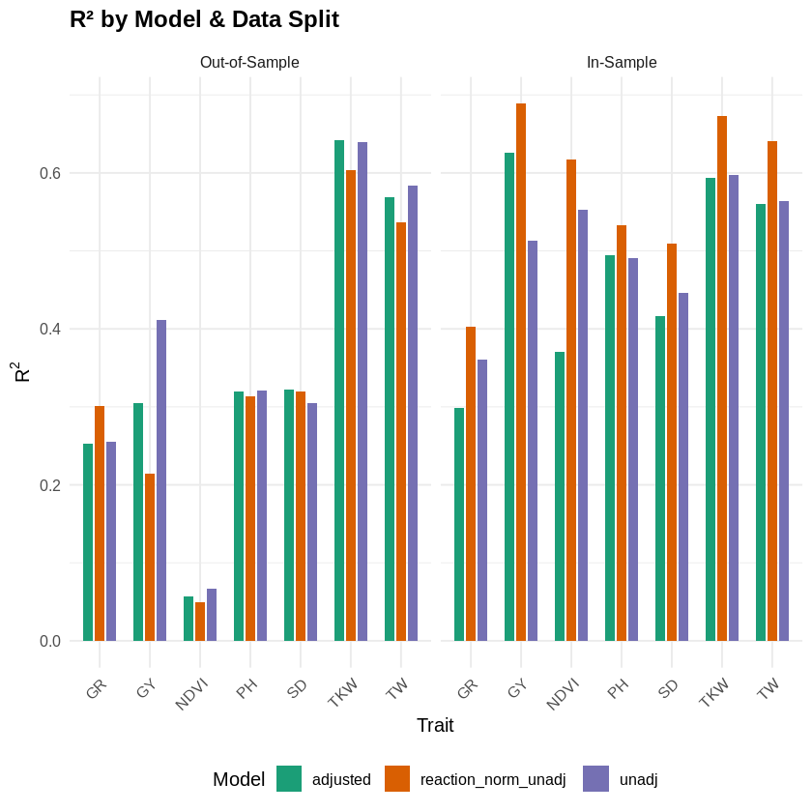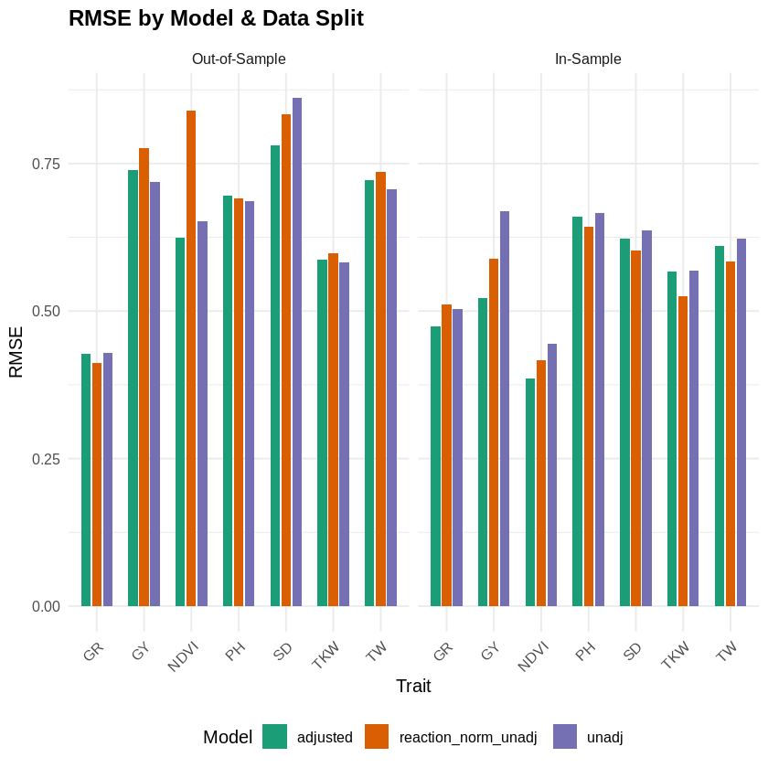
Figure 2. Comparative predictive performance of three modeling approaches – drought adjusted (green), reaction norm (orange), and unadjusted (purple) – across seven traits. Left panels show out-of-sample and in-sample R²; right panels show corresponding RMSE values. Traits include grain yield (GY), senescence date (SD), plant height (PH), normalized difference vegetation index (NDVI), green reflectance (GR), thousand kernel weight (TKW), and test weight (TW). Higher R² and lower RMSE indicate better model performance.
NDVI & Green Reflectance (GR)
High GxE for NDVI led to mixed outcomes. Reaction norm achieved the highest in‑sample R² and best AIC but performed worst for test RMSE and repeatability. Pre‑adjustment scored best on BIC, training RMSE, and test RMSE. In GWAS, baseline BLUPs showed strong yet diffuse signals, with pre-adjustment sharpening known peaks on 2D, 5A, and 5B most cleanly, while reaction norm dampened the 2D locus and elevated new candidates on 1A, 4A, and 4B. Figure 6 visually summarizes NDVI modeling results.
Reaction norm modeling delivered the strongest overall performance for GR, yielding the highest repeatability, best AIC/BIC, and lowest test RMSE. Pre-adjustment gave the lowest training RMSE, but reaction norm minimized prediction error on the hold-out. In GWAS, reaction norm attenuated major associations on 1A, 2B, and 5A – especially the 5B locus – redistributing signal intensity across the genome. Pre-adjustment maintained the 1A peak while reducing the 5B signal relative to baseline. Figure 7 visually summarizes GR modeling results.
Kernel Traits (TKW, TW)
Differences among models for TKW were minimal. Reaction norm slightly outperformed in-sample but underperformed on the test set despite the highest repeatability. AIC favored reaction norm, whereas BIC ranked it lowest. Baseline GWAS highlighted a strong 4B peak that reaction norm nearly eliminated; pre-adjustment elevated a 4A locus above 4B, and reaction norm further strengthened a 5A association. Known 3D and 6B associations remained stable across all approaches. Figure 8 visually summarizes TKW modeling results.
TW results closely mirrored those for TKW: model metrics were essentially indistinguishable, with no clear “best” approach. In GWAS, the baseline 2A signal vanished under reaction norm, and pre‑adjustment brought a 3D locus to prominence above both 2A and 4A. A robust 6B association persisted consistently across all three models. Figure 9 visually summarizes TW modeling results.
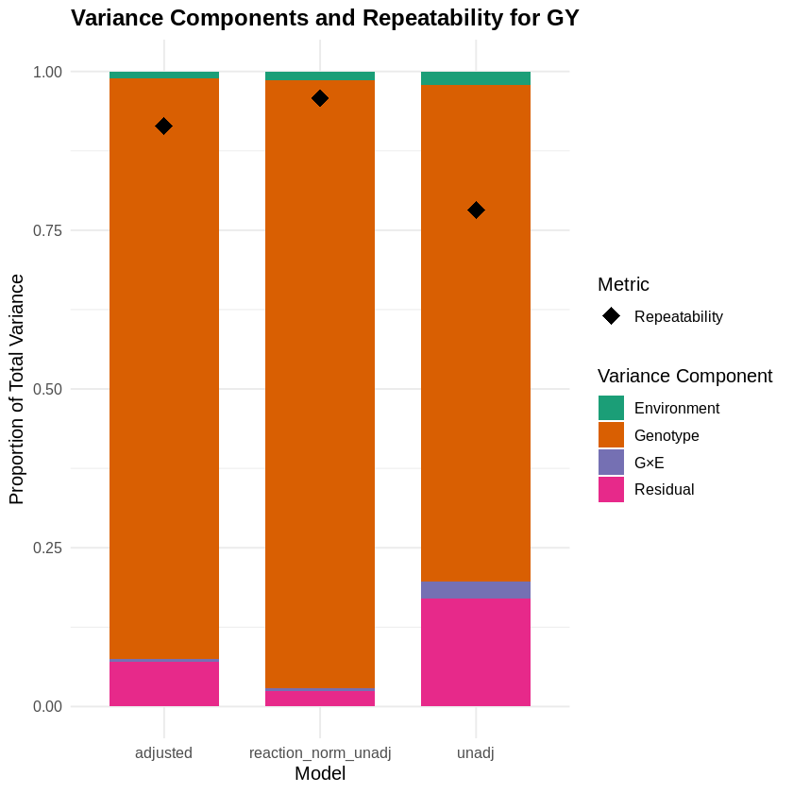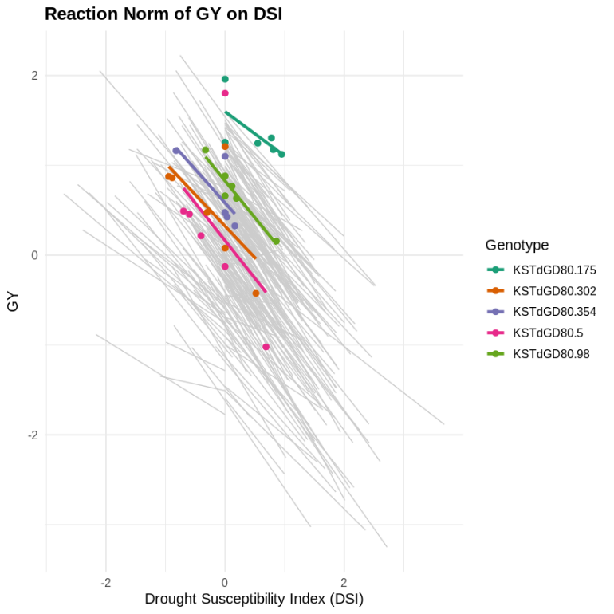
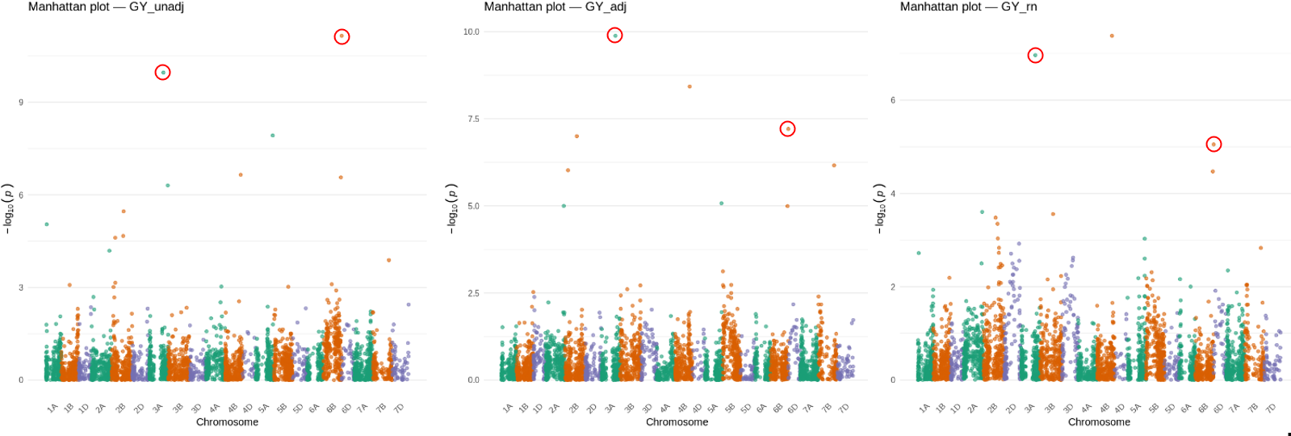
Figure 3. Multi-panel summary of modeling outcomes for grain yield (GY) under three approaches. The top left panel shows the proportion of total variance explained by environment (green), genotype (orange), GxE (purple), and residual (pink) for the baseline, pre-adjusted, and reaction norm models. Black diamonds denote genetic repeatability for each approach. The top right panel shows reaction norm slopes of individual genotypes’ GY responses to the drought susceptibility index (DSI), with 5 random genotypes highlighted, with points corresponding to within-environment performance. The bottom panels show Manhattan plots of -log₁₀(p) from BLINK GWAS on BLUPs derived from unadjusted (bottom-left), pre-adjusted (bottom-middle), and reaction norm (bottom-right) models. Red circles mark significant loci discussed in text body, illustrating how drought correction shifts association signal strength and ranking.

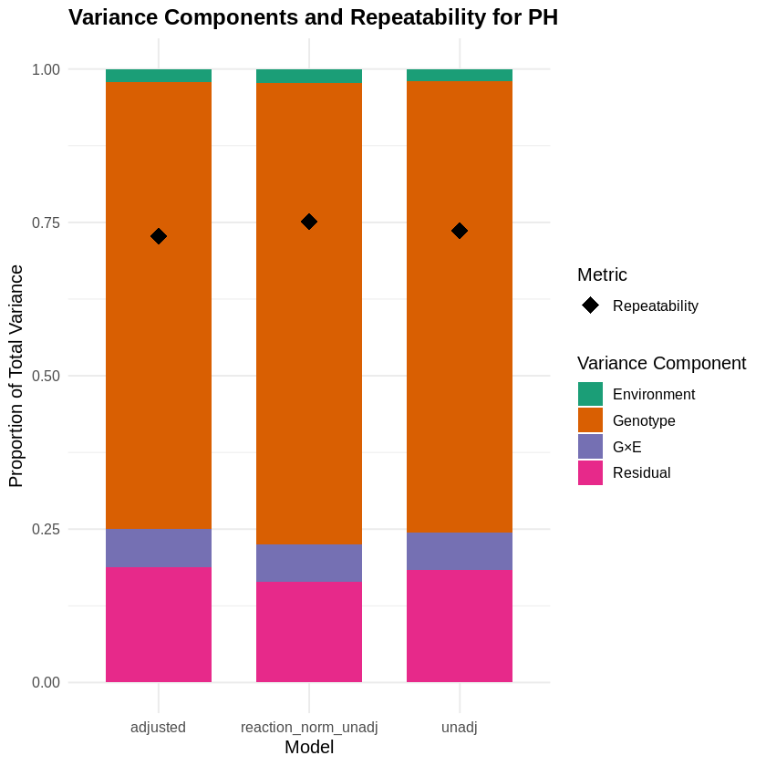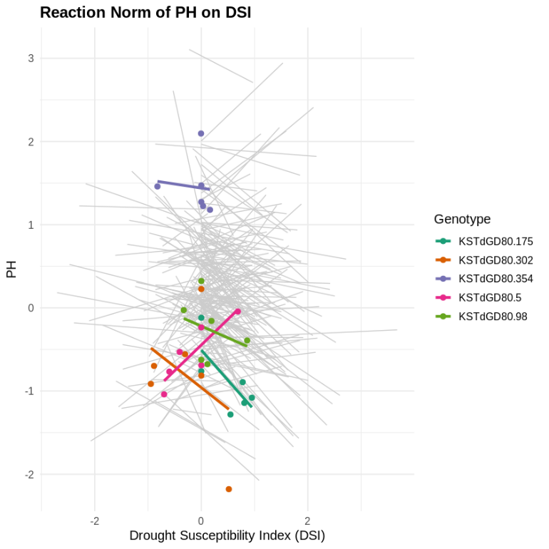
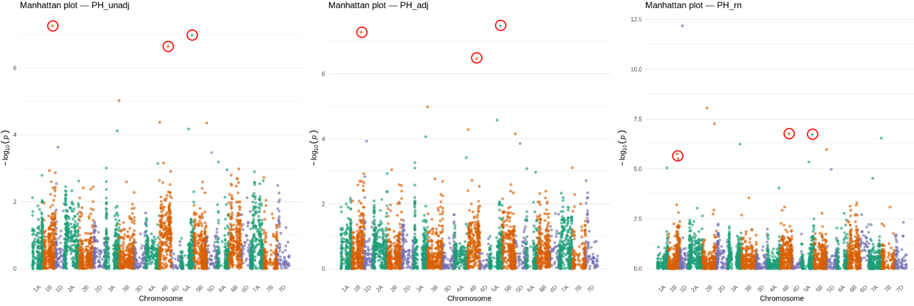
Figure 4. Multi-panel summary of modeling outcomes for plant height (PH) under three approaches. The top left panel shows the proportion of total variance explained by environment (green), genotype (orange), GxE (purple), and residual (pink) for the baseline, pre-adjusted, and reaction norm models. Black diamonds denote genetic repeatability for each approach. The top right panel shows reaction norm slopes of individual genotypes’ PH responses to the drought susceptibility index (DSI), with 5 random genotypes highlighted, with points corresponding to within-environment performance. The bottom panels show Manhattan plots of -log₁₀(p) from BLINK GWAS on BLUPs derived from unadjusted (bottom-left), pre-adjusted (bottom-middle), and reaction norm (bottom-right) models. Red circles mark significant loci discussed in text body, illustrating how drought correction shifts association signal strength and ranking.
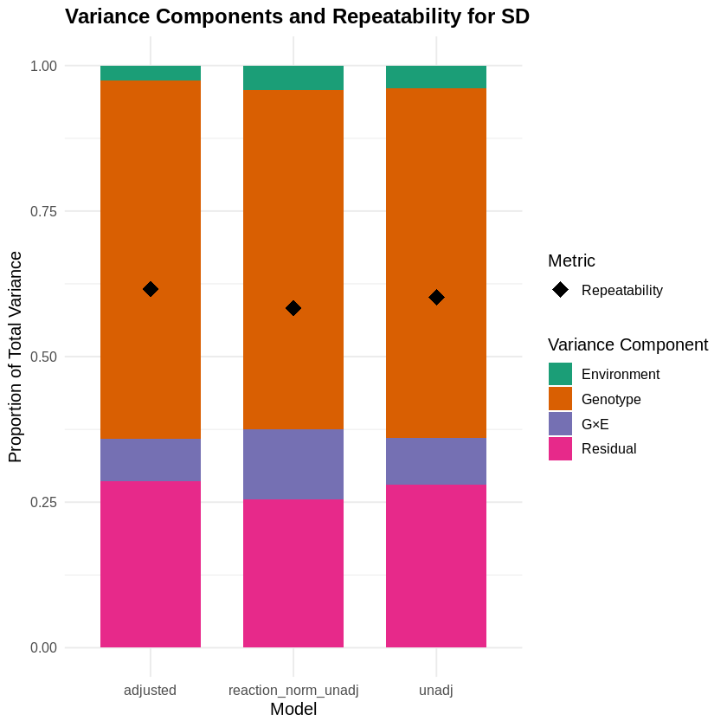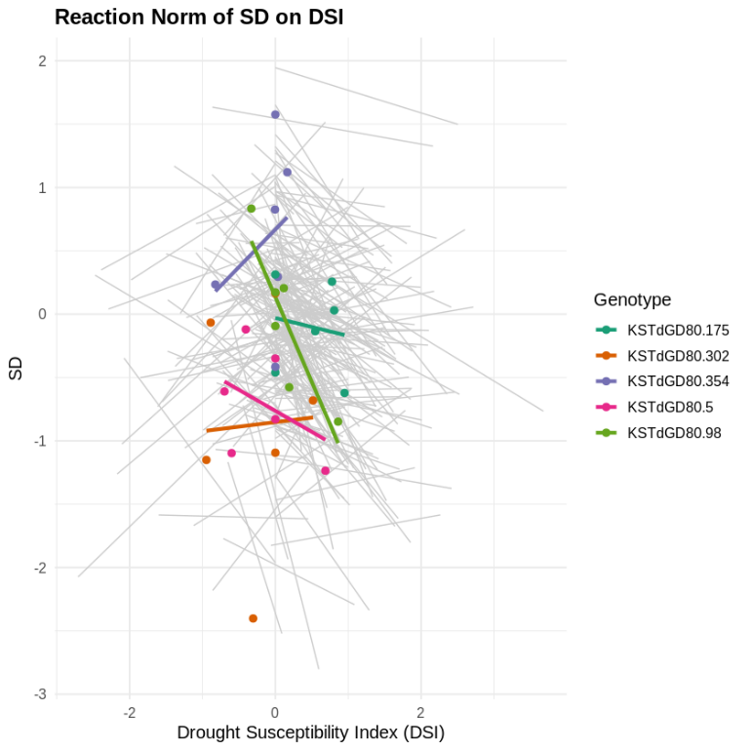
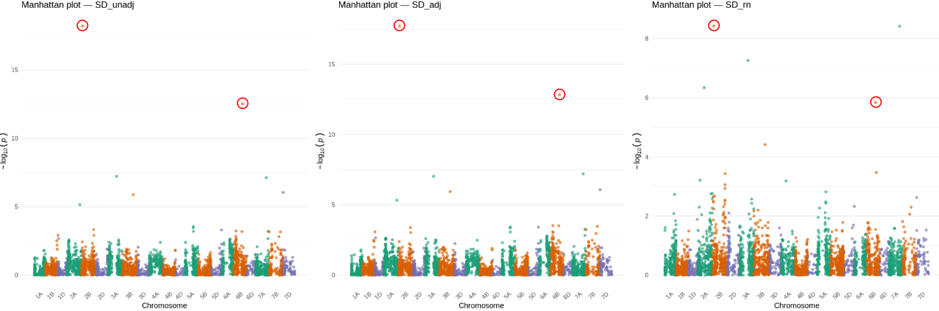
Figure 5. Multi-panel summary of modeling outcomes for senescence date (SD) under three approaches. The top left panel shows the proportion of total variance explained by environment (green), genotype (orange), GxE (purple), and residual (pink) for the baseline, pre-adjusted, and reaction norm models. Black diamonds denote genetic repeatability for each approach. The top right panel shows reaction norm slopes of individual genotypes’ SD responses to the drought susceptibility index (DSI), with 5 random genotypes highlighted, with points corresponding to within-environment performance. The bottom panels show Manhattan plots of -log₁₀(p) from BLINK GWAS on BLUPs derived from unadjusted (bottom-left), pre-adjusted (bottom-middle), and reaction norm (bottom-right) models. Red circles mark significant loci discussed in text body, illustrating how drought correction shifts association signal strength and ranking.

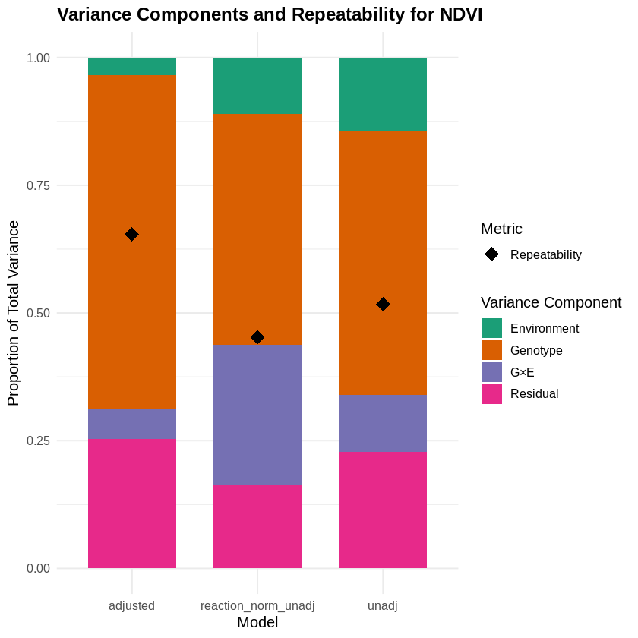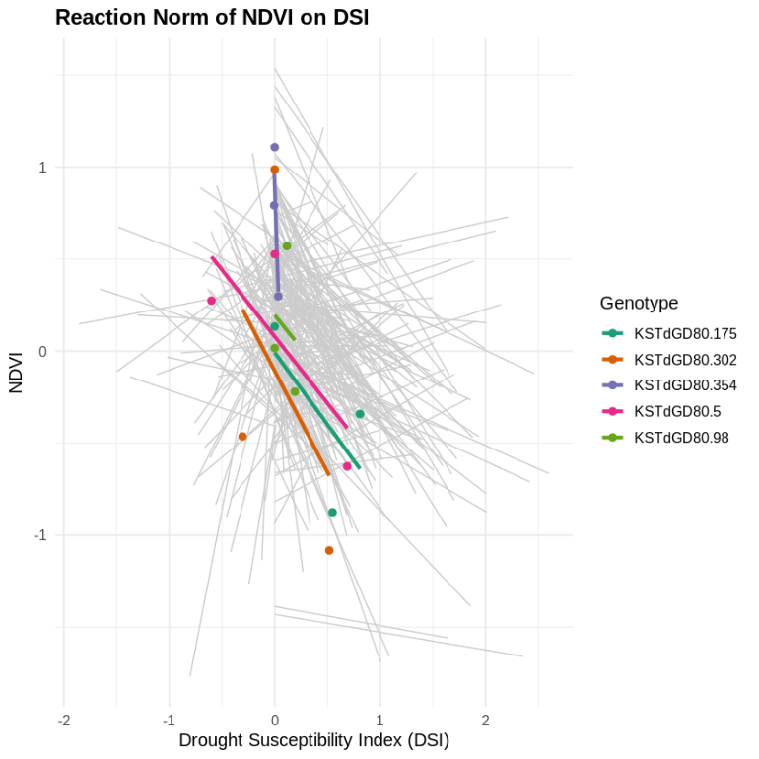
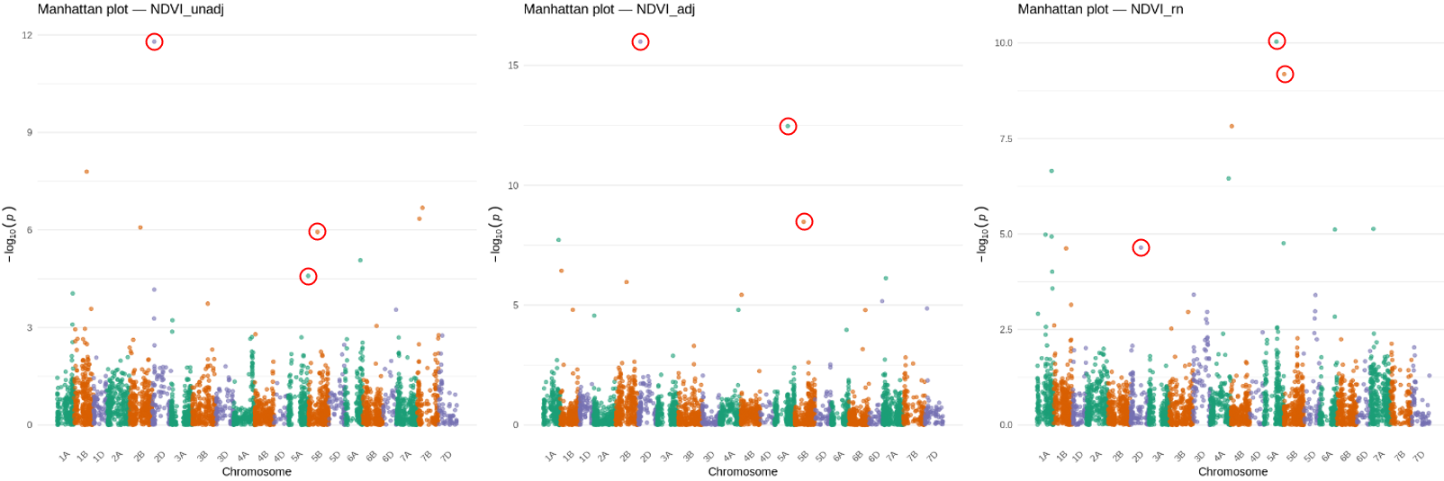
Figure 6. Multi-panel summary of modeling outcomes for normalized difference vegetation index (NDVI) under three approaches. The top left panel shows the proportion of total variance explained by environment (green), genotype (orange), GxE (purple), and residual (pink) for the baseline, pre-adjusted, and reaction norm models. Black diamonds denote genetic repeatability for each approach. The top right panel shows reaction norm slopes of individual genotypes’ NDVI responses to the drought susceptibility index (DSI), with 5 random genotypes highlighted, with points corresponding to within-environment performance. The bottom panels show Manhattan plots of -log₁₀(p) from BLINK GWAS on BLUPs derived from unadjusted (bottom-left), pre-adjusted (bottom-middle), and reaction norm (bottom-right) models. Red circles mark significant loci discussed in text body, illustrating how drought correction shifts association signal strength and ranking.
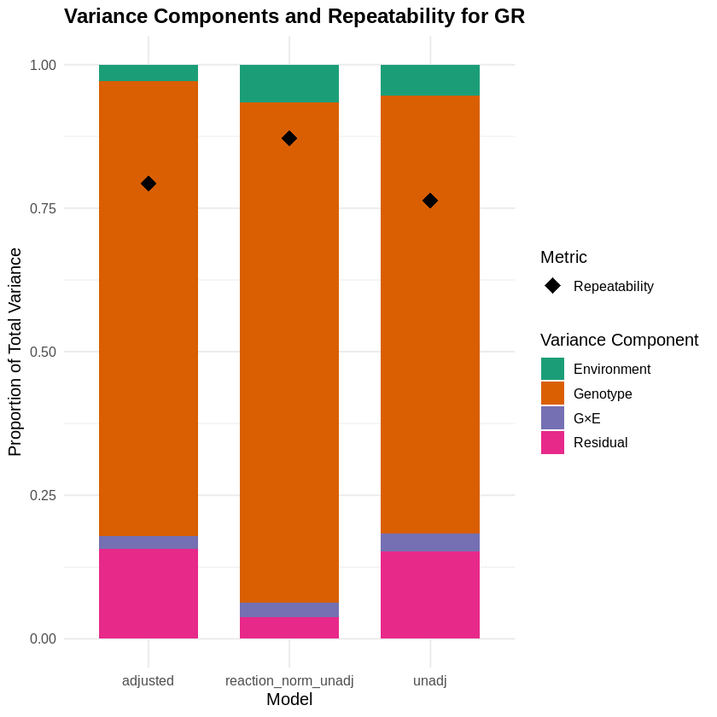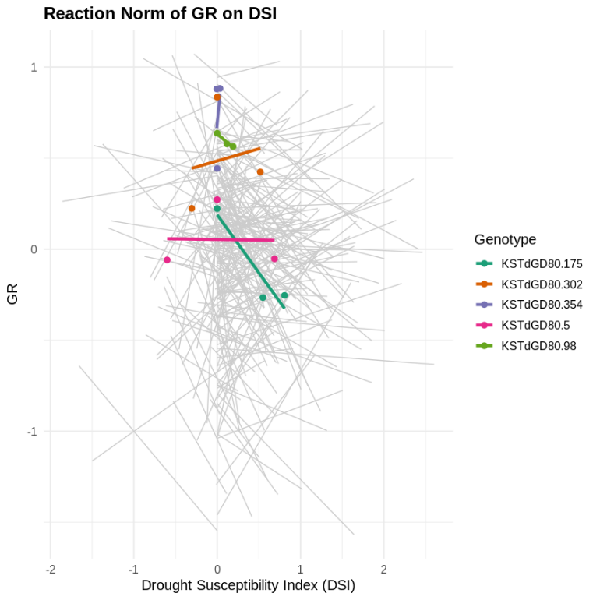
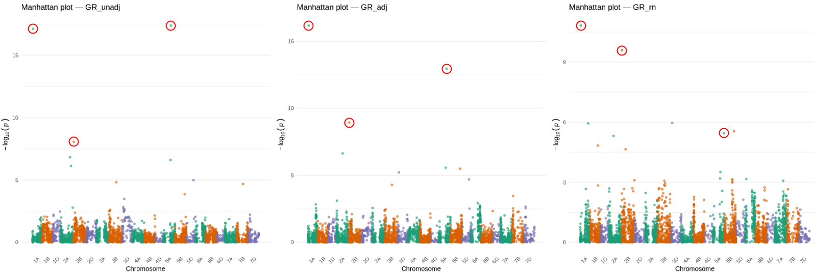
Figure 7. Multi-panel summary of modeling outcomes for green reflectance (GR) under three approaches. The top left panel shows the proportion of total variance explained by environment (green), genotype (orange), GxE (purple), and residual (pink) for the baseline, pre-adjusted, and reaction norm models. Black diamonds denote genetic repeatability for each approach. The top right panel shows reaction norm slopes of individual genotypes’ GR responses to the drought susceptibility index (DSI), with 5 random genotypes highlighted, with points corresponding to within-environment performance. The bottom panels show Manhattan plots of -log₁₀(p) from BLINK GWAS on BLUPs derived from unadjusted (bottom-left), pre-adjusted (bottom-middle), and reaction norm (bottom-right) models. Red circles mark significant loci discussed in text body, illustrating how drought correction shifts association signal strength and ranking.
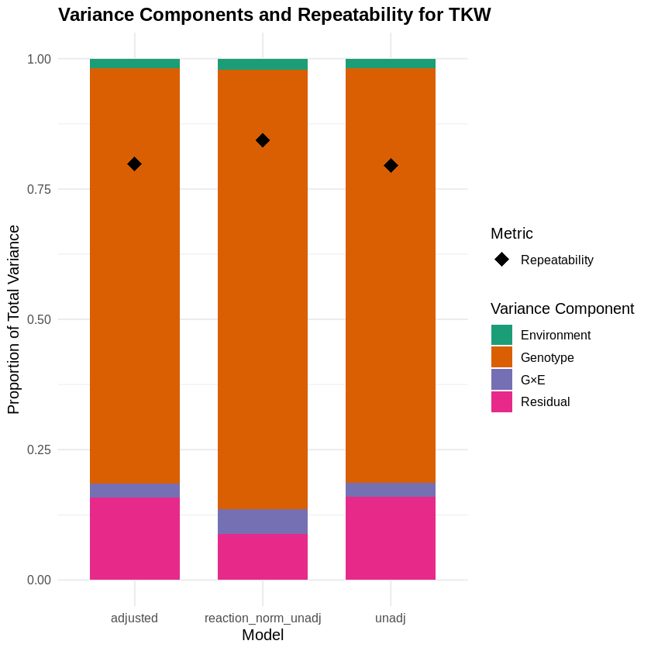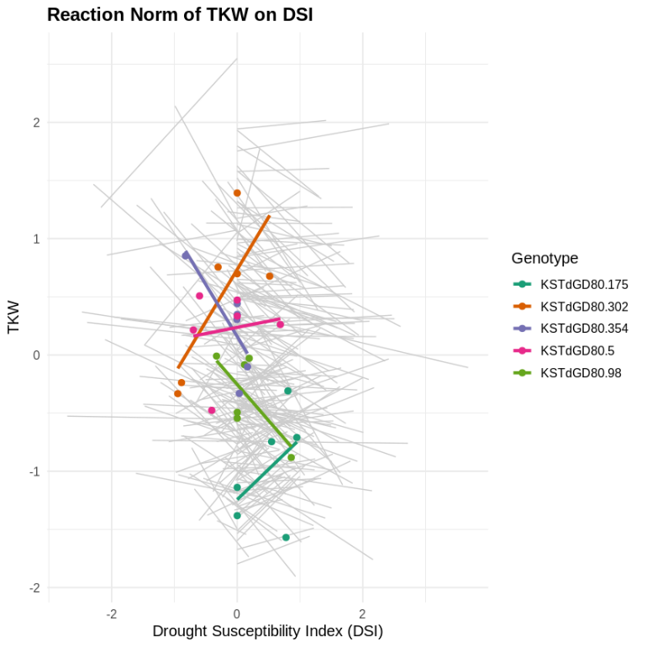
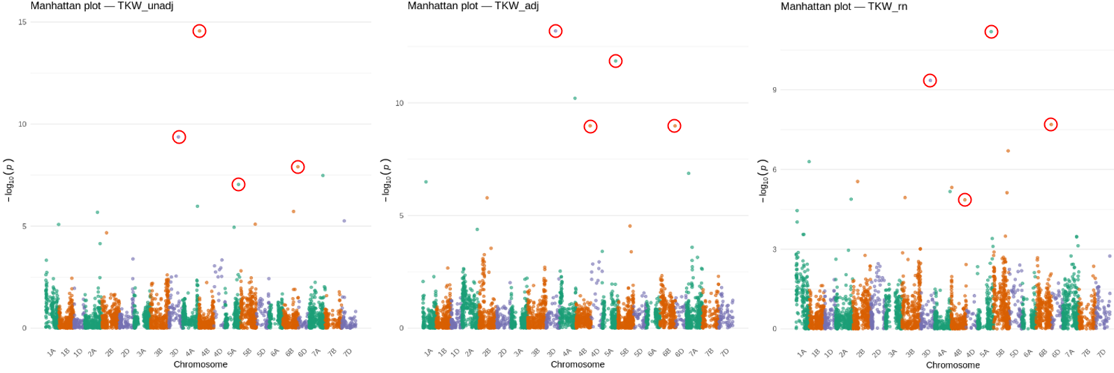
Figure 8. Multi-panel summary of modeling outcomes for thousand kernel weight (TKW) under three approaches. The top left panel shows the proportion of total variance explained by environment (green), genotype (orange), GxE (purple), and residual (pink) for the baseline, pre-adjusted, and reaction norm models. Black diamonds denote genetic repeatability for each approach. The top right panel shows reaction norm slopes of individual genotypes’ TKW responses to the drought susceptibility index (DSI), with 5 random genotypes highlighted, with points corresponding to within-environment performance. The bottom panels show Manhattan plots of -log₁₀(p) from BLINK GWAS on BLUPs derived from unadjusted (bottom-left), pre-adjusted (bottom-middle), and reaction norm (bottom-right) models. Red circles mark significant loci discussed in text body, illustrating how drought correction shifts association signal strength and ranking.
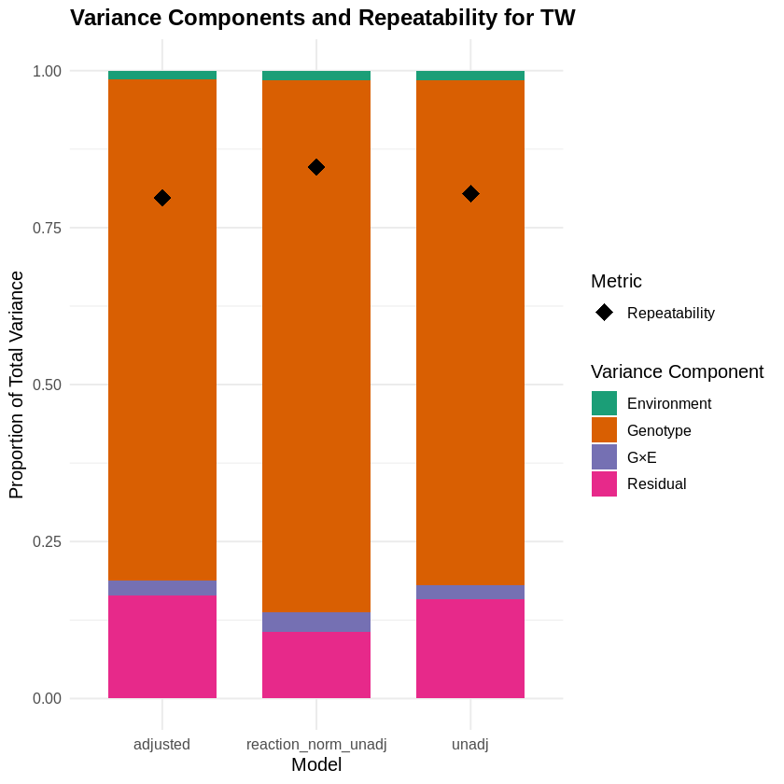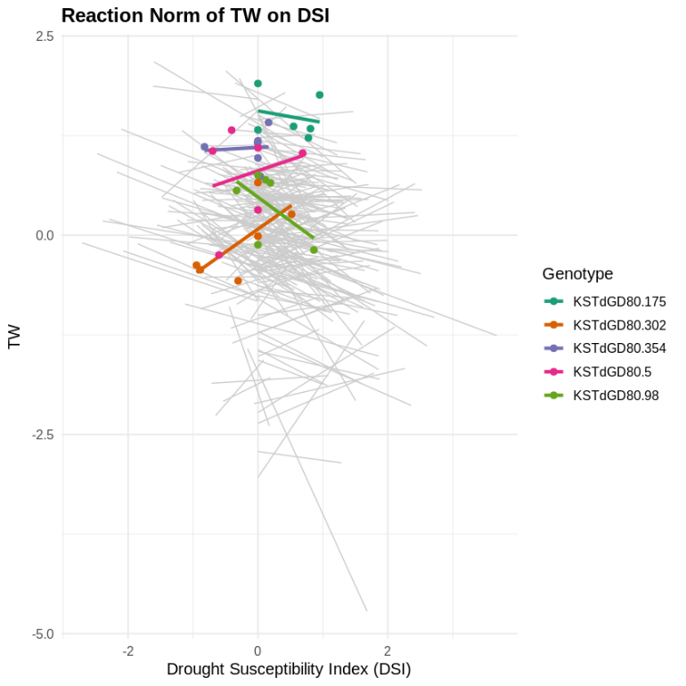
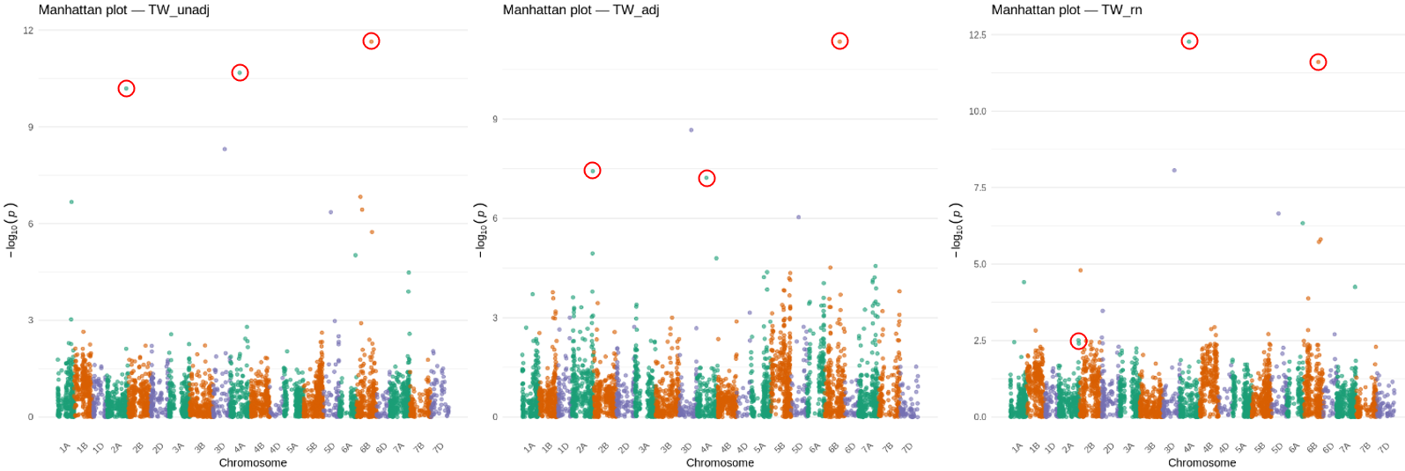
Figure 9. Multi-panel summary of modeling outcomes for test weight (TW) under three approaches. The top left panel shows the proportion of total variance explained by environment (green), genotype (orange), GxE (purple), and residual (pink) for the baseline, pre-adjusted, and reaction norm models. Black diamonds denote genetic repeatability for each approach. The top right panel shows reaction norm slopes of individual genotypes’ TW responses to the drought susceptibility index (DSI), with 5 random genotypes highlighted, with points corresponding to within-environment performance. The bottom panels show Manhattan plots of -log₁₀(p) from BLINK GWAS on BLUPs derived from unadjusted (bottom-left), pre-adjusted (bottom-middle), and reaction norm (bottom-right) models. Red circles mark significant loci discussed in text body, illustrating how drought correction shifts association signal strength and ranking.

Table 3. BLINK GWAS association summary across three modeling approaches for seven traits – grain yield (GY), senescence date (SD), plant height (PH), normalized difference vegetation index (NDVI), green reflectance (GR), thousand kernel weight (TKW), and test weight (TW). “X” denotes a strong association detected under that modeling approach; “-“ indicates that the locus was identified by other approaches for that trait but not by the one listed.
trait | model | Chromosome
 |  | 1A | 1B | 1D | 2A | 2B | 2D | 3A | 3D | 4A | 4B | 5A | 5B | 6B | 7A
SD | unadj |  |  |  |  | X |  |  |  |  |  |  |  | X | -
SD | adjusted |  |  |  |  | X |  |  |  |  |  |  |  | X | -
SD | reaction_norm |  |  |  |  | X |  |  |  |  |  |  |  | X | X
PH | unadj |  | X | - |  | - |  |  |  |  | X | X
PH | adjusted |  | X | - |  | - |  |  |  |  | X | X
PH | reaction_norm |  | - | X |  | X |  |  |  |  | X | X
NDVI | unadj | - |  |  |  |  | X |  |  | - | - | - | -
NDVI | adjusted | - |  |  |  |  | X |  |  | - | - | X | X
NDVI | reaction_norm | X |  |  |  |  | - |  |  | X | X | X | X
GR | unadj | X |  |  |  | X |  |  |  |  |  | X
GR | adjusted | X |  |  |  | X |  |  |  |  |  | X
GR | reaction_norm | X |  |  |  | X
GY | unadj |  |  |  |  |  |  | X |  |  | - |  |  | X
GY | adjusted |  |  |  |  |  |  | X |  |  | X |  |  | X
GY | reaction_norm |  |  |  |  |  |  | X |  |  | X |  |  | X
TKW | unadj |  |  |  |  |  |  |  | X | - | X | X |  | X
TKW | adjusted |  |  |  |  |  |  |  | X | X | X | X |  | X
TKW | reaction_norm |  |  |  |  |  |  |  | X | - | - | X |  | X
TW | unadj |  |  |  | X |  |  |  | - | X |  |  |  | X
TW | adjusted |  |  |  | X |  |  |  | X | X |  |  |  | X
TW | reaction_norm |  |  |  | - |  |  |  | X | X |  |  |  | X

Discussion
These results demonstrate that incorporating a data-derived drought susceptibility index (DSI) effectively reallocates phenotypic variance toward the genotypic component – particularly for grain yield (GY), from which DSI is directly derived. The baseline approach, however, outperformed drought-informed approaches in out-of-sample prediction (2022 RL), suggesting that correction for data-driven drought-related variance introduces an ascertainment bias that can lead to overfitting when the same trait underlies both the index and the response. This finding underscores the classic tension between bias correction and prediction robustness.
Secondary component traits showed more nuanced responses to DSI correction. Plant height (PH) and senescence date (SD), both known to be affected under water deficit (Blum, 2015), exhibited nearly identical predictive metrics across models. Reaction-norm modeling (Approach 3) did uncover additional marker-trait associations – such as loci on 1D and 2B for PH – yet key known QTL (e.g., the Rht-b1 height locus on 4B; Ellis et al., 2002) remained detectable regardless of drought adjustment, indicating true genetic control that transcends water availability.
Normalized difference vegetation index (NDVI) presented the greatest GxE challenge, with high environmental variance diluting repeatability. While reaction norm achieved superior in-sample fit, its out-of-sample performance and inflated marker discovery caution against assuming all emergent signals reflect genuine GxE decomposition rather than noise (Jarquín et al., 2014).
Green reflectance (GR) benefited most consistently from reaction-norm modeling, attaining the highest repeatability, optimal AIC/BIC, and lowest test RMSE. Although major associations on chromosomes 1A and 2B were retained, the 5B peak collapsed under reaction norm – potentially indicating that this locus primarily drives GR variation under drought stress rather than baseline chlorophyll content.
Thousand kernel weight (TKW) and test weight (TW) showed marginal model differences, but compelling GWAS shifts: the dominant 4B signal for TKW vanished under reaction norm, while pre-adjustment amplified a 4A locus. For TW, a 2A association disappeared under reaction norm, and a 3D marker emerged only after linear DSI correction. These patterns suggest that accounting for drought can both clarify and obscure kernel trait genetics, depending on whether associations reflect general or stress-specific physiology.
Across traits, the persistent 6B region – which repeatedly surfaced for GY, SD, TKW, and TW – hints at a pleiotropic QTL governing nutrient remobilization and grain filling under terminal drought (Saradadevi et al., 2017). Such convergent signals highlight the complex architecture of yield components, especially under water stress, and warrant targeted validation.
In sum, DSI-based modeling increases the genetic signal in multi-environment trials but carries a trade-off between reduced bias under stress and decreased predictive generality. Reaction-norm models excel at partitioning GxE but may overfit under heavy environmental variance, whereas simple linear pre-adjustment offers computational ease with potential inflation of genetic repeatability estimates. For traits with moderate drought sensitivity, unadjusted or linearly adjusted models may suffice; for strongly stress-responsive traits like GR, reaction norms provide clear gains. Ultimately, model choice should reflect the biological question – predicting performance across diverse patterns of water availability versus isolating stress-specific genetic effects – and be guided by validation in independent environments.

References
Blum, A. (2015). Towards a conceptual ABA ideotype in plant breeding for water-limited environments. Functional Plant Biology, 42(6), 502–513.
Butler, D. G., Cullis, B. R., Gilmour, A. R., Gogel, B. G., & Thompson, R. (2023). ASReml-R Reference Manual Version 4.2. VSN International Ltd.
de los Campos, G., Naya, H., Gianola, D., Crossa, J., Legarra, A., Manfredi, E., Weigel, K., & Cotes, J. M. (2009). Predicting quantitative traits with regression models for dense molecular markers and pedigree. Genetics, 182(1), 375–385.
Dolferus, R., Thavamanikumar, S., Sangma, H., Kleven, S., Wallace, X., Forrest, K., Rebetzke, G., Hayden, M., Borg, L., Smith, A., & Cullis, B. (2019). Determining the genetic architecture of reproductive stage drought tolerance in wheat using a correlated trait and correlated marker effect model. G3: Genes|Genomes|Genetics, 9(2), 473–488.
Ellis, M., Spielmeyer, W., Gale, K., Rebetzke, G., & Richards, R. A. (2002). “Perfect” markers for the Rht-B1b and Rht-D1b dwarfing genes in wheat. Theoretical and Applied Genetics, 105(6), 1038–1042.
Estrada, F., Flexas, J., Araus, J. L., Mora-Poblete, F., Gonzalez-Talice, J., Castillo, D., Matus, I. A., Mendez-Espinoza, A. M., Garriga, M., Araya-Riquelme, C., Douthe, C., Castillo, B., del Pozo, A., & Lobos, G. A. (2023). Exploring plant responses to abiotic stress by contrasting spectral signature changes. Frontiers in Plant Science, 13, 1026323.
Fischer, R. A., & Maurer, R. (1978). Drought resistance in spring wheat cultivars. I. Grain yield responses. Australian Journal of Agricultural Research, 29, 897–912.
Gianola, D., de los Campos, G., Hill, W. G., Manfredi, E., & Fernando, R. (2009). Additive genetic variability and the Bayesian alphabet. Genetics, 183(1), 347–363.
Gilmour, A. R., Cullis, B. R., & Verbyla, A. P. (1997). Accounting for natural and extraneous variation in the analysis of field experiments. Journal of Agricultural, Biological, and Environmental Statistics, 2(3), 269–293.
Huang, M., Liu, X., Zhou, Y., Summers, R. M., & Zhang, Z. (2018). BLINK: a package for the next level of genome-wide association studies with both individuals and markers in the millions. GigaScience, 8(2), giy154.
Jarquín, D., Crossa, J., Lacaze, X., Du Cheyron, P., Daucourt, J., Lorgeou, J., Piraux, F., Guerreiro, L., Pérez, P., Calus, M., Burgueño, J., & de los Campos, G. (2014). A reaction norm model for genomic selection using high-dimensional genomic and environmental data. Theoretical and Applied Genetics, 127(3), 595–607.
Ji, L., Senay, G. B., Friedrichs, M., Schauer, M., & Boiko, O. (2021). Characterization of water use and water balance for the croplands of Kansas using satellite, climate, and irrigation data. Agricultural Water Management, 256, 107106.
Kansas Mesonet. (2025). Kansas Mesonet historical data. Retrieved May 14, 2025, from https://mesonet.k-state.edu/climate/precip/county/
Onyemaobi, O., Sangma, H., Garg, G., Wallace, X., Kleven, S., Suwanchaikasem, P., Roessner, U., & Dolferus, R. (2021). Reproductive stage drought tolerance in wheat: Importance of stomatal conductance and plant growth regulators. Genes, 12(11), 1742.
Pérez, P., & de los Campos, G. (2014). Genome-wide regression and prediction with the BGLR statistical package. Genetics, 198(2), 483–495.
Saradadevi, R., Palta, J. A., & Siddique, K. H. M. (2017). ABA-mediated stomatal response in regulating water use during the development of terminal drought in wheat. Frontiers in Plant Science, 8, 1251.
Wang, J., & Zhang, Z. (2021). GAPIT Version 3: Boosting power and accuracy for genomic association and prediction. Genomics, Proteomics & Bioinformatics, 19(4), 629–640.
Zhang, Z., Ersoz, E., Lai, C.-Q., Todhunter, R. J., Tiwari, H. K., Gore, M. A., Bradbury, P. J., Yu, J., Arnett, D. K., Ordovas, J. M., & Buckler, E. S. (2010). Mixed linear model approach adapted for genome-wide association studies. Nature Genetics, 42(4), 355–360.

